PIZZA SALES SQL QUERIES

1. ---Total Revenue---

Select Sum (total_price) AS Total_Revenue From [Pizza Sales]



1. ---Average Order Value

Select Sum(total_price)/Count(Distinct order_id) as Avg_Order_Value From [Pizza Sales]



1. ---Total Pizza Sold---

Select Sum(quantity) As Total_Pizza_Sold From [Pizza Sales]



1. ---Total Orders Placed---

Select Count(Distinct order_id) As Total_Order_Placed from [Pizza Sales]



1. ---Average Pizzas Per Order---

Select ROUND(Sum(quantity)/Count(Distinct order_id),2) As Average_Pizzas_Per_orders from [Pizza Sales]



1. ---Daily Trend For Total Orders---

Select DATENAME(DW,order_date) As order_day,Count(Distinct order_id) As Total_orders

from [Pizza Sales]

Group By DATENAME(DW,order_date)

Order By Total_orders Desc

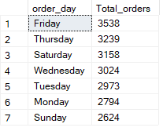

1. ---Monthly Trend For Total Orders---

Select DATENAME(MONTH ,order_date) As Month_Name,Count(Distinct order_id) As Total_orders

from [Pizza Sales]

Group By DATENAME(MONTH,order_date)

Order By Total_orders Desc

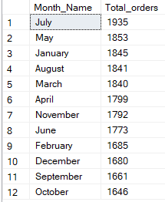

1. ---Percentage Of Sales By Pizza Category---

Select pizza_category, Sum(total_price) as Total_Sales, Sum(total_price)*100 / (Select Sum(total_price) From [Pizza Sales]) As PCT

From [Pizza Sales]

Group By pizza_category

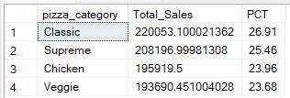

1. ---Percentage Of Sales By Pizza Size---

Select pizza_size, Sum(total_price) as Total_Sales, Round(Sum(total_price)*100 / (Select Sum(total_price) From [Pizza Sales]),2) As PCT

From [Pizza Sales]

Group By pizza_size

Order By PCT Desc

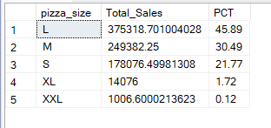

1. ---Total Pizza Sold By Pizza Category---

SELECT pizza_category, SUM(quantity) as Total_Quantity_Sold

FROM [Pizza Sales]

GROUP BY pizza_category

ORDER BY Total_Quantity_Sold DESC

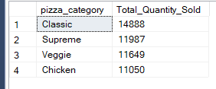

1. ---Total Pizza Sold By Pizza Size---

SELECT pizza_size, SUM(quantity) as Total_Quantity_Sold

FROM [Pizza Sales]

GROUP BY pizza_size

ORDER BY Total_Quantity_Sold DESC

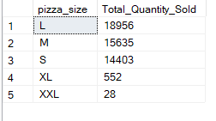

1. ---Top 5 By Revenue---

Select Top 5 pizza_name, Sum(total_price) As Total_Revenue From [Pizza Sales]

Group By pizza_name

Order By Total_Revenue Desc

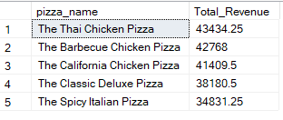

1. ---Bottom 5 By Revenue---

Select Top 5 pizza_name, Sum(total_price) As Total_Revenue From [Pizza Sales]

Group By pizza_name

Order By Total_Revenue Asc

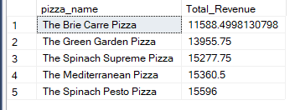

1. ---Top 5 Pizza By Quantity---

Select Top 5 pizza_name, Sum(quantity) As Total_Quantity From [Pizza Sales]

Group By pizza_name

Order By Total_Quantity Desc

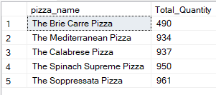

1. ---Bottom 5 Pizza By Quantity---

Select Top 5 pizza_name, Sum(quantity) As Total_Quantity From [Pizza Sales]

Group By pizza_name

Order By Total_Quantity Asc

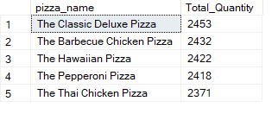

1. ---Top 5 Pizzas By Total Orders---

Select Top 5 pizza_name, Count (Distinct order_id) As Total_Orders From [Pizza Sales]

Group By pizza_name

Order By Total_Orders Desc

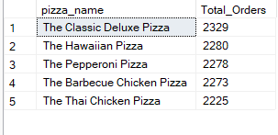

1. ---Bottom 5 Pizzas By Total Orders---

Select Top 5 pizza_name, Count (Distinct order_id) As Total_Orders From [Pizza Sales]

Group By pizza_name

Order By Total_Orders Asc

